Name: Varlene

Surname: Sibanda

Student Number: ST10276007

Module: SOEN6222 – Assignment 2

The Microservices architecture is a design approach that divides a large application into smaller, autonomous, and highly specialized services. Each service handles specific functionalities, operates independently, and communicates with other services through well-defined APIs or messaging protocols. This architecture aligns perfectly with the Helping Hands platform’s needs for scalability, flexibility, resilience, and maintainability. In the Helping Hands platform, these services include User Management, Volunteer Management, Donations, Resource Distribution, Event Management, and Feedback Collection. Each service operates independently and performs tasks related to its domain. (anuupadhyay, 2023) (satyabrata_jena, 2024)

### How Microservices Architecture Works (Umesh, 2024):

* Independent Deployment and Operations: Each microservice can be developed, tested, deployed, and scaled individually, which reduces the risks associated with modifying the entire system. For example, the User Management Service can be updated or scaled without affecting the Donations or Event Management services.
* Communication via APIs or Messaging: The services communicate with each other through APIs or messaging systems. For instance, when a donation is made, the Donations Service may trigger an API call to the Resource Distribution Service to update inventory levels if the donation includes physical items.
* Data and State Management: Each microservice manages its own database or data storage, ensuring that data integrity is maintained. For example, the Volunteer Management Service will have its own data store for tracking volunteer hours, while the Donations Service manages donation histories.

### Motivation for Choosing Microservices Architecture (kuprenko, 2019):

* Scalability: Microservices architecture allows for independent scaling of services. For example, if only the Donations Service needs to be scaled up to handle increased transaction volume, other services such as Volunteer Management remain unaffected depending on the requirements.
* Flexibility: The modular nature of microservices allows the Helping Hands platform to evolve rapidly. New features such as additional payment methods for donations, or new volunteer programs, can be developed and deployed independently, without requiring changes to the entire system.

Each microservice can be developed using the best-suited technology stack. For example, Node.js might be used for the Donations Service for real-time transaction processing, while Python could handle inventory management.

* Maintainability: Updates, bug fixes, and improvements can be applied to individual services without causing downtime for the whole platform. For instance, an enhancement in the Resource Distribution Service won’t disrupt the User Management or Donations services.

The separation of concerns ensures that the development team can focus on a specific part of the platform without being overwhelmed by its complexity.

* Resilience: In microservices architecture, the failure of one service does not crash the entire system. For instance, if the Event Management Service goes down, volunteers can still register, and donations can still be processed.
* Technology and Future Growth: Microservices support diverse technologies, allowing the development team to select the most appropriate tools for each service. This flexibility is crucial as Helping Hands grows, and new technological needs emerge.

The platform can easily integrate with external systems like payment gateways or third-party APIs for future enhancements.

Key Design Elements

1. Service-Oriented Modules  
   Each microservice aligns with a business capability:
   * User Management: Manages user roles and authentication.
   * Resource Distribution: Ensures accurate inventory tracking and allocation.
2. API Gateway
   * A centralized API Gateway mediates all interactions between microservices and external clients, providing security, routing, and throttling.
3. Database per Service
   * Each service maintains its own database, ensuring data separation and preventing inter-service dependency.
4. Continuous Deployment
   * CI/CD pipelines ensure rapid delivery of updates and bug fixes with minimal disruptions.
5. Event-Driven Communication
   * Services publish and subscribe to events using messaging systems like RabbitMQ or Kafka.

### Conclusion:

Microservices architecture is ideal for the Helping Hands Software Solution due to its scalability, flexibility, maintainability, and resilience. It allows each service to scale independently, supports rapid feature development, and ensures the platform can handle growing demands and complex functionality efficiently. As Helping Hands expands, this architecture will provide the efficiency and agility needed for sustained success.

Question 2 – UML Class Diagram

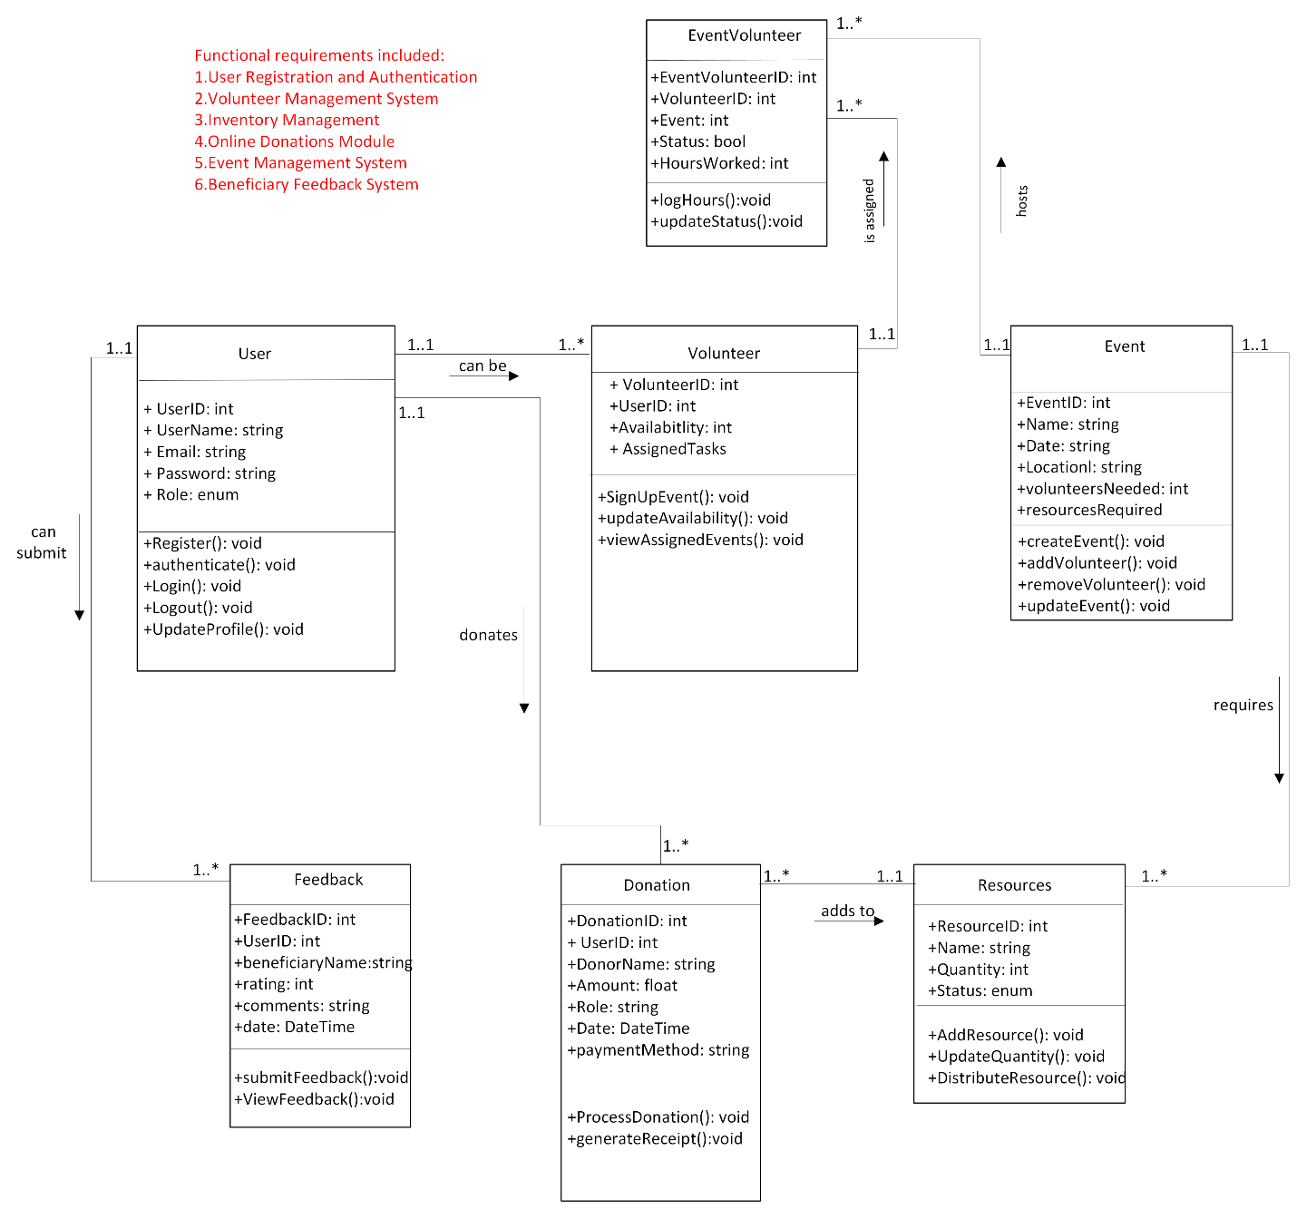

Appendix: Addressing Updates

The updated design document enhances clarity by expanding on key aspects of the microservices architecture, including how independent deployment, API communication, and database management support scalability and resilience.

* Examples contextualize abstract concepts, making them relatable to Helping Hands’ operations.
* The motivation section highlights specific scenarios where microservices excel, like scaling the Donations Service or integrating external APIs.
* Design elements such as the API Gateway, event-driven communication, and CI/CD pipelines have been introduced to reflect modern best practices.

These updates ensure a comprehensive understanding of how the architecture supports Helping Hands’ mission to grow and adapt efficiently.

# Bibliography

anuupadhyay. (2023, November 06). *geeksforgeeks*. Retrieved from geeksforgeeks: https://www.geeksforgeeks.org/microservice-architecture-introduction-challenges-best-practices/

kuprenko. (2019, November 14). *stackify*. Retrieved from stackify: https://stackify.com/6-key-benefits-of-microservices-architecture/#:~:text=Microservices%20make%20it%20easier%20to%20test%2C%20understand%2C%20and,it%20easier%20to%20create%20applications%20with%20microservice%20architecture.

satyabrata_jena. (2024, June 20). *geeksforgeeks*. Retrieved from geeksforgeeks: https://www.geeksforgeeks.org/types-of-software-architecture-patterns/#5-microservices-pattern

Umesh. (2024, October 22). *utho*. Retrieved from utho: https://utho.com/blog/what-are-microservices-architecture/